Right from the beginning of mankind, there was always a way to get paid up lawfully and securely so that the buyer wouldn’t escape his/her dues.

And in the modern-day era, Invoicing is one of the ways you get paid lawfully and securely.

## The Definition of an Invoice

An Invoice is a piece of document that you ( Supplier ) will send to your customer ( Buyer ) requesting the payment you are due for providing a service.

And this service could be anything like:

* Designing a website
* Representing your customer as a Lawyer
* Providing security services
* And the list goes on and on

But you get the idea, right?

Here is an example of an invoice:

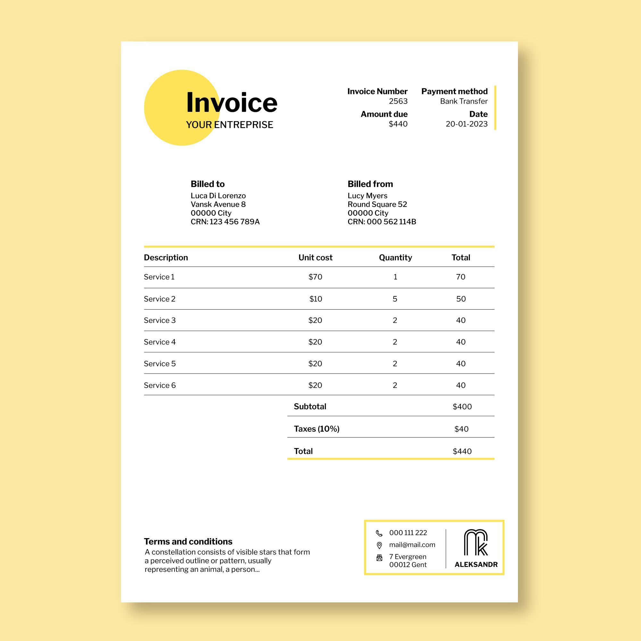

Credits: [Image by Freepik](https://www.freepik.com/)

A wise man once said:

*“Beware of little expenses, a small leak will sink a great ship”  
-Benjamin Franklin*

### And here are a few important things that should include in your invoice:

* Name and logo of your business
* Contact details of your business
* Customer name and contact details
* Date the invoice was created
* Due date of the amount owed
* Description of the item or service
* Amount due (if you are offering more than one item, include single unit cost and number of units along with the total)
* Your preferred method of payment and payment details
* Invoice terms including the interest rate if your payment is overdue

When you’re writing the invoice, it’s important that the details are clear and the invoice has a professional look. This is the information your customer will need to pay you correctly and on time.

## How to create an Invoice using Criya

[How To Invoice Clients & Avoid Late Payments | FREE Invoice Template](https://www.youtube.com/watch?v=bu7DVXU4T1Y)

Here is a comparison table with our competitors:

|  | **Leafbooks** | **A & Invoicing** | **Criya** |
| --- | --- | --- | --- |
| Contact Details |  |  |  |
| Payment Information |  |  |  |
| Reference Number |  |  |  |
| Breakdown of Costs |  |  |  |
| Scrum Boards |  |  |  |
| Pricing | **$49 / Month** | **$59 / Month** | **$39 / Month** |

## And here is some cool invoicing inspiration to get you creative

Credits: Images are downloaded from [Canva.com](https://www.canva.com/)

